**Power and Energy.**

**Power**

Power is defined as **the rate of doing work.** It is also defined as the amount of energy transferred or converted per unit time. P o w e r = W o r k d o n e T i m e t a k e n. The SI unit of power is watt. One watt is 1 joule per second.

**UNIT**

The symbol for power is P, and the SI unit for power is the **watt (W)**

**Energy**

Scientists define energy as **the ability to do work**. Modern civilization is possible because people have learned how to change energy from one form to another and then use it to do work.

**UNIT**

The SI unit of energy **is joule.**

**POWER DISSIPATION IN RESISTOR.**

In the field of electronics, power dissipation is also a measurement parameter that quantifies the releasing of heat within a circuit due to inefficiencies. In other words, power dissipation is a measure of how much power (P = I x E) in a circuit is converted into heat.

To calculate power dissipated in a resistor, use the formula P = VI or P = I²R. Power dissipated in a resistor refers to the amount of energy that is converted into heat as electric current flows through it.

## Kirchhoff’s laws

Kirchhoff’s laws mainly deal with voltage and current in the electrical circuits.

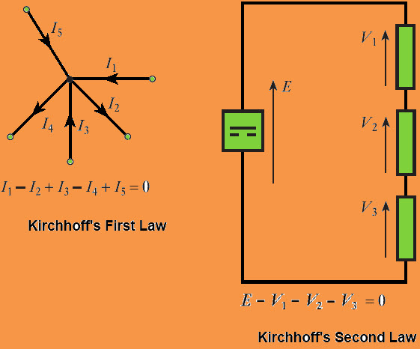

There are various relationships among voltages and currents of an electrical circuit. These relationships are determined by Kirchhoffs laws such as KVL and KCL. These laws are used to determine the impedance of the complex network or equivalent electrical resistance and the currents flowing in the several branches of the n/w.

### Kirchhoff Current Law

KCL or Kirchhoffs current law or Kirchhoffs first law states that the total current in a closed circuit, the entering current at node is equal to the current leaving at the node or the algebraic sum of current at node in an electronic circuit is equal to zero.

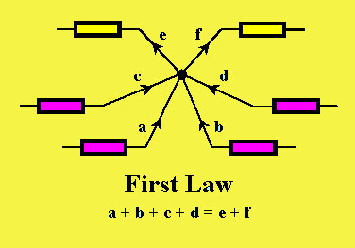

**Kirchhoff’s Current Law**

In the above diagram, the currents are denoted with a,b,c,d and e. According to the KCL law, the entering currents are a,b,c,d and the leaving currents are e and f with negative value. The equation can be written as

**a+b+c+d= e + f**

### Kirchhoff Voltage Law

KVL or Kirchhoff’s voltage law or Kirchhoffs second law states that, the algebraic sum of the voltage in a closed circuit is equal to zero or the algebraic sum of the voltage at node is equal to zero.

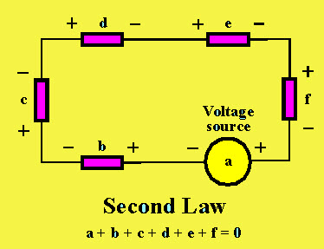

**Kirchhoff’s Voltage Law**

Kirchhoff's current law and voltage law, defined by Gustav Kirchhoff,